Stationery Inventory System - Logic University

UI Walkthrough - Department

Revision 1

Table of Contents

Web UIs

Department Log In UIs

Stationery Requisition Form

View Order Status

View Order Status - Specific Selection

View Product Catalogue

View Disbursement List

Appoint Location (Designated Collection Point)

Approval/Rejection of Requisition Form

Appointment of Representative

Authorizing Department Staff

Mobile UIs

# Web UIs

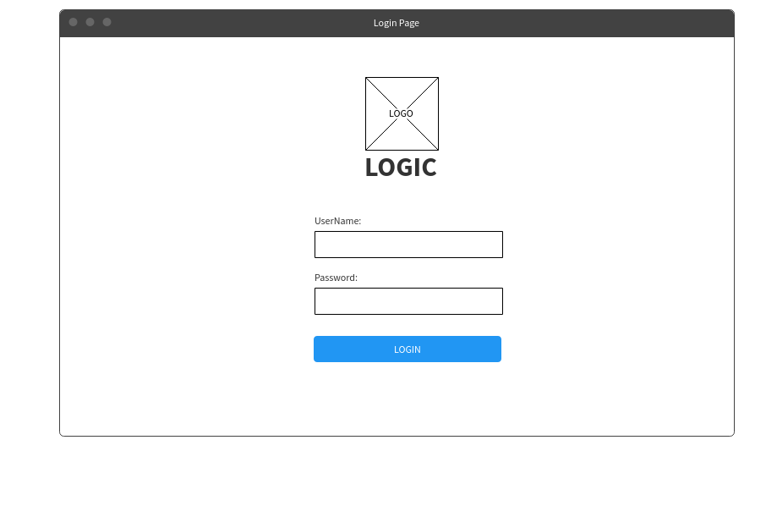

This is the login screen which will be used by the department head and employee.

## Department Log In UIs

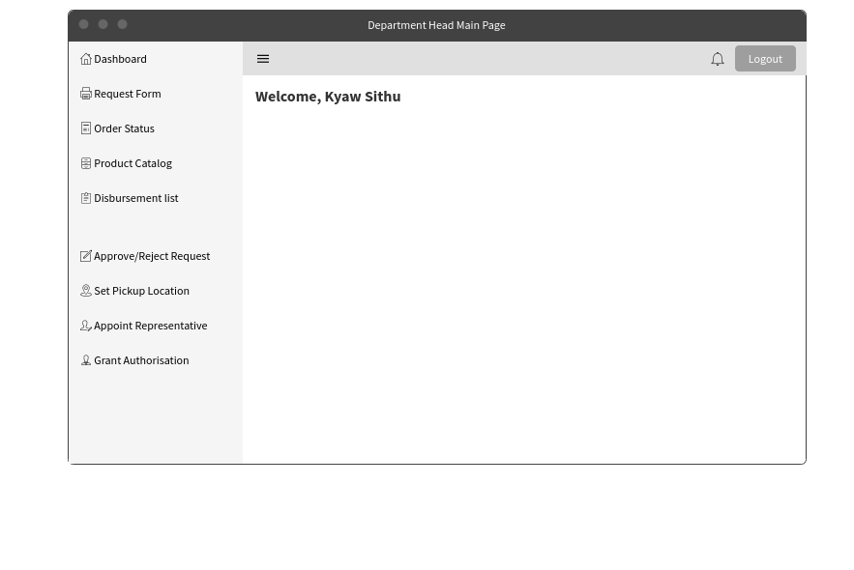

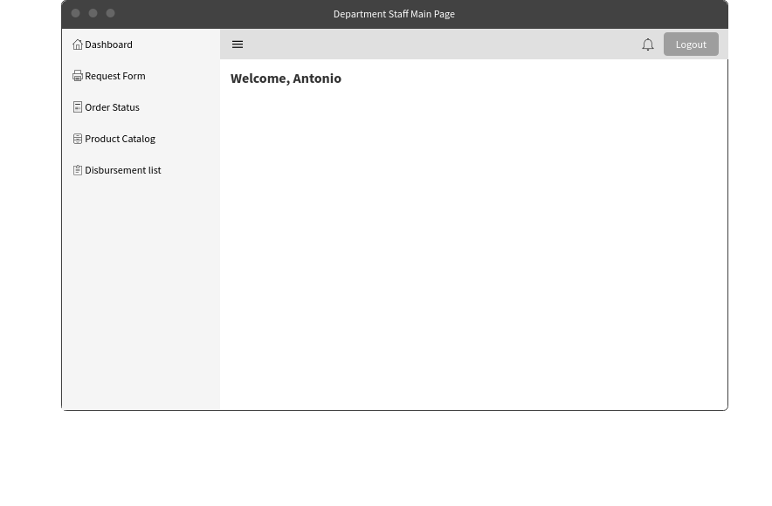

These 2 screens are the main pages after logging in. The one above will be viewed by the department head while the one below will be viewed by the staff.

## Stationery Requisition Form

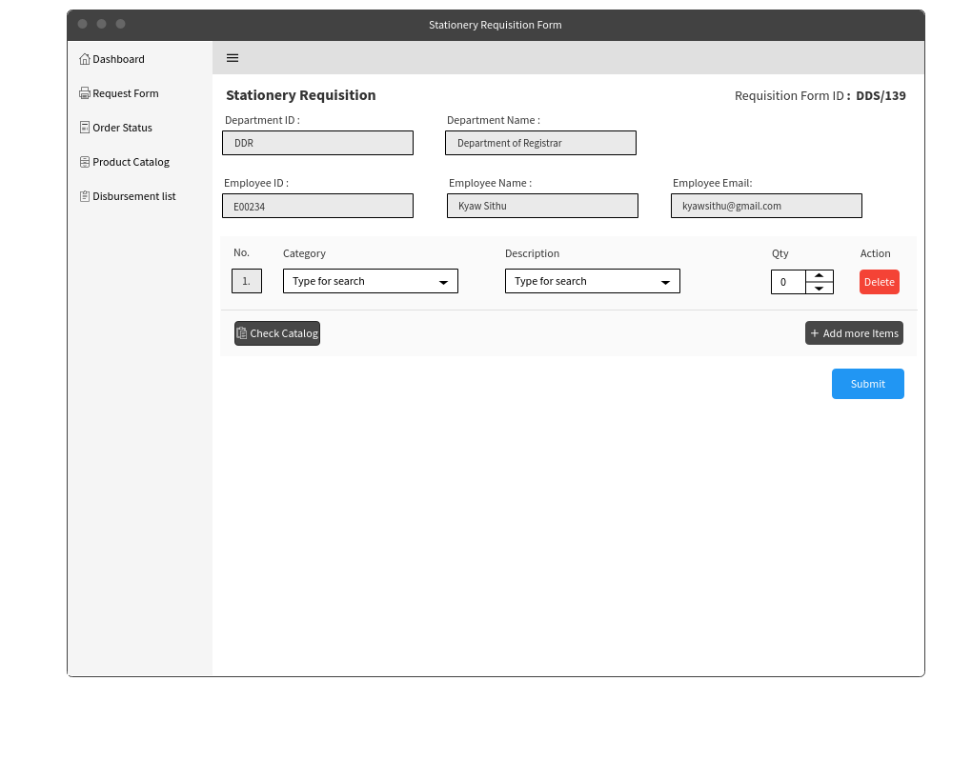

Upon clicking on the request form, the above page will be shown. This page is to submit a request for items that are needed in the department. Users will first select from a Category of item (i.e Pen, Envelope, Paper etc). Once selected, the category’s specific item selection will be presented in a dropdown box. A check catalog button has been included to pop-up a catalogue window in case there is a need to refer to it.

## View Order Status

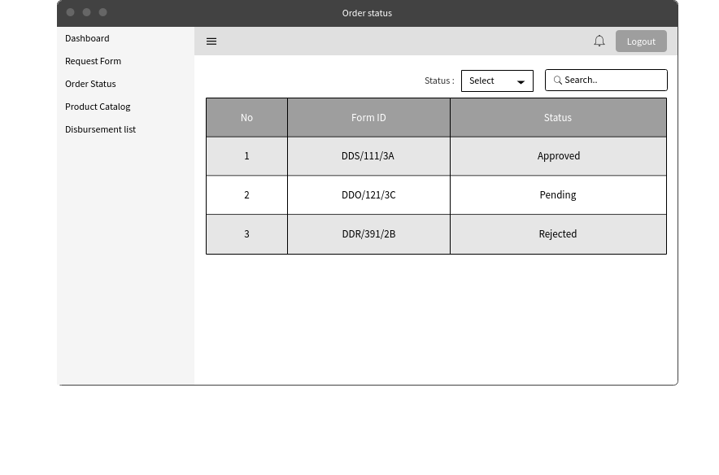

This page is the order status page and can be accessed after clicking on the order status on the left side of the page. Tracking of the form’s status can be done here. Sorting of the status can be done from the drop-down list and searching for specific form can also be done by searching for its unique form ID.

## View Order Status - Specific Selection

This is the screen after clicking on specific form ID on the order status. The employee can view the detailed version of what they have ordered and the remark provided by the manager is he rejects it.

## View Product Catalogue

After choosing the product catalogue option on the left side of the screen, a list of stationery that is available to the employees to request. Employees are also able to search for the type of products that they are looking for.

## View Disbursement List

After choosing the disbursement list option on the left side of the screen, a list of disbursement list would be shown. This would allow for the departments to have a copy of the disbursement list that was signed during collection. Having a copy of the disbursement list would help the departments during times of dispute about the stock amount collected or amount to make payment.

## Appoint Location (Designated Collection Point)

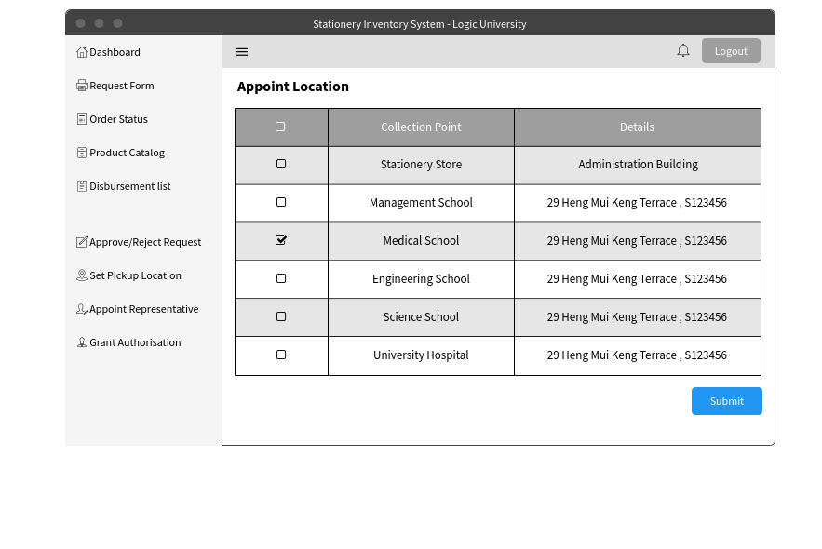

The following screen will be seen and used by the department head. The Department Head will be able to select their department’s chosen location from the listing of available locations. Upon clicking “submit”, it will be set for all stationery orders until the next change.

An additional functionality is added here whereby users are unable to change this location once the day crosses Wednesday 18:00 hours. This is to prevent collection location from changing at the last minute when store clerks are busy collecting stocks and assembling them from disbursement.

## Approval/Rejection of Requisition Form

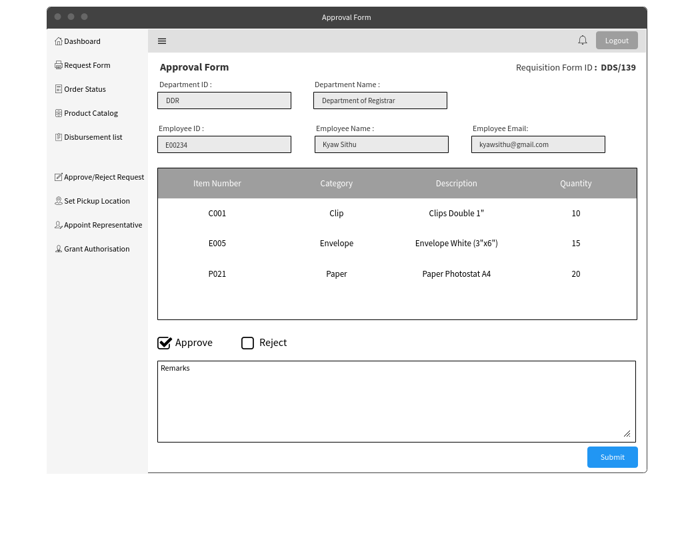

This is the view of the approval and rejection screen. The details of the employee and department would be shown on the top. The details of the stationery that the employee would like to request would be shown below the employee details. Two options of approve or reject would be given so that the decision can be made. The approver would be allowed to give their remarks when they either approve or reject the request. Upon clicking the submit button an email would be sent to the employee and the store clerk to notify them of the approval.

## Appointment of Representative

The page above will be shown after clicking on the appoint representative option on the left. An employee name can be entered or clicking the list button will show a list of employee’s name. Upon clicking submit, an email and notification will be sent to that specific employee.

## Authorizing Department Staff

Above shows the authorization page that is accessible by Department Heads. Here, the Department Heads are able to assign approval role to their staff. They will also need to choose a duration of which they want to assign this role to. For easy viewing, an Employee List is included by the side for reference, so that Department Heads are able to view their staff list in the event they require it.

# Mobile UIs

Below UIs are the android screens for Department Head.

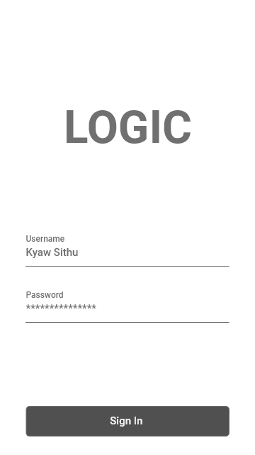

Enter correct username and password to sign in to account.

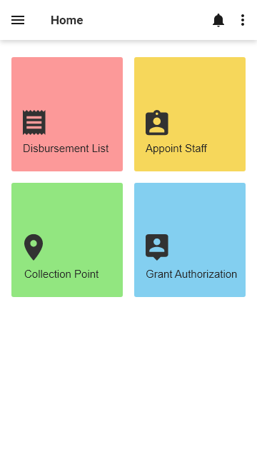

This is the home page for department android application. Clicking the disbursement button will lead you to disbursement list. To appoint representative and collection location, click appoint staff and collection point respectively. Grant Authorization button is to give permission to staff to approve or reject the requisition when the department head is on leave.

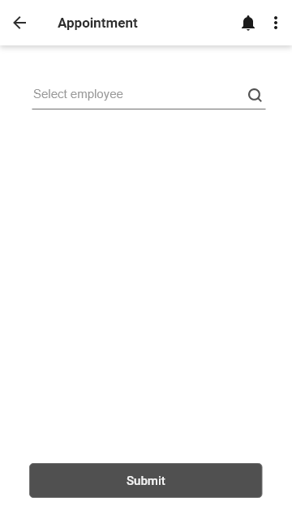

Search for the employee and submit to appoint as department department representative. The search box support with auto-complete and suggestion box.

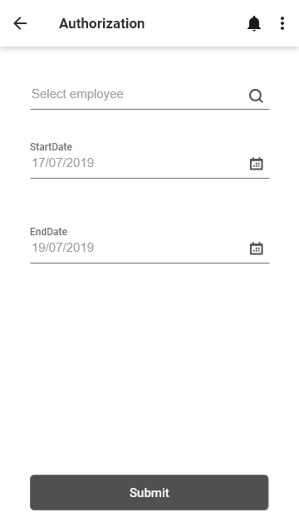

Search employee, select start date and end date to grant permission to that employee.

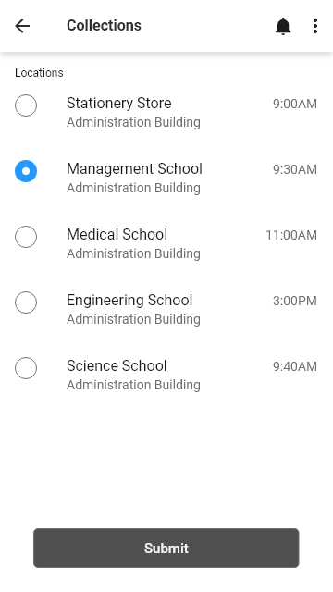

The following list is the collection point locations. Select one to choose which place to collect the ordered items.

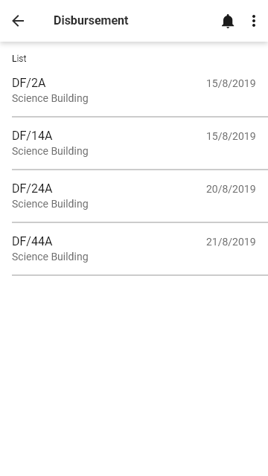

The following list is the disbursement list. Click one to check which items the store be in debt to the department

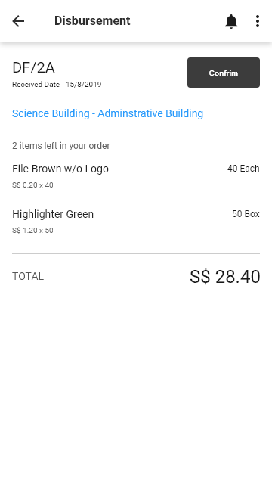

Upon clicking on the specific item on the disbursement list, a detailed information regarding the items not given will be shown.